Test Case: tc002_SPX_Dev5_Crear_Requisicion_Spot_Con_FAD_Tipo_Cobro_CC
Step 1 - Enter username and password and click to button Enter : Credentials Entered
Image file-name: QC_Testing-tc002_SPX_Dev5_Crear_Requisicion_Spot_Con_FAD_Tipo_Cobro_CC-1790170336551

Step 2 - Select to UEN and Access to Spot Buy Requisitions : UEN Correctly selected and Correct access
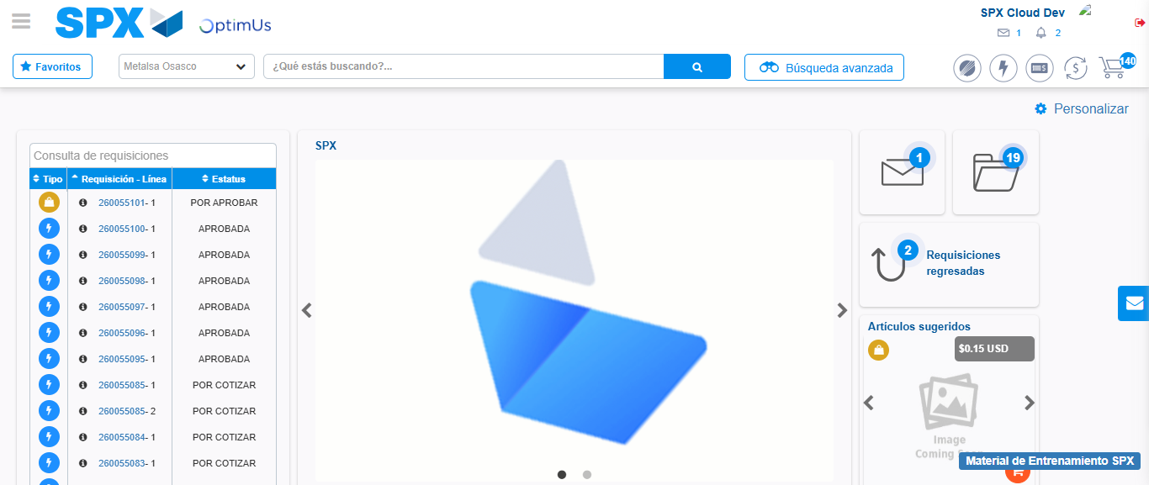Image file-name: QC_Testing-tc002_SPX_Dev5_Crear_Requisicion_Spot_Con_FAD_Tipo_Cobro_CC-1790170360873

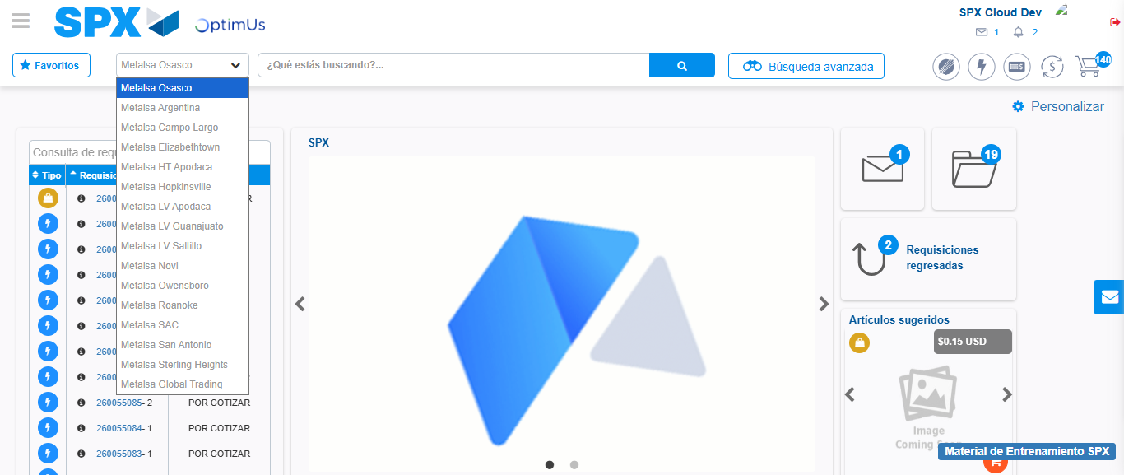Image file-name: QC_Testing-tc002_SPX_Dev5_Crear_Requisicion_Spot_Con_FAD_Tipo_Cobro_CC-1790170361494

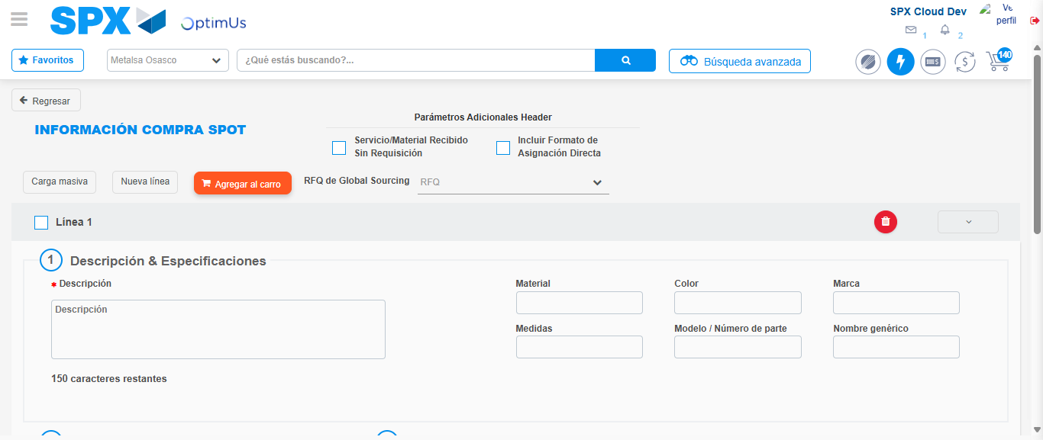Image file-name: QC_Testing-tc002_SPX_Dev5_Crear_Requisicion_Spot_Con_FAD_Tipo_Cobro_CC-1790170371298

Step 3 - Add FAD to Requisition: FAD Successfully Added
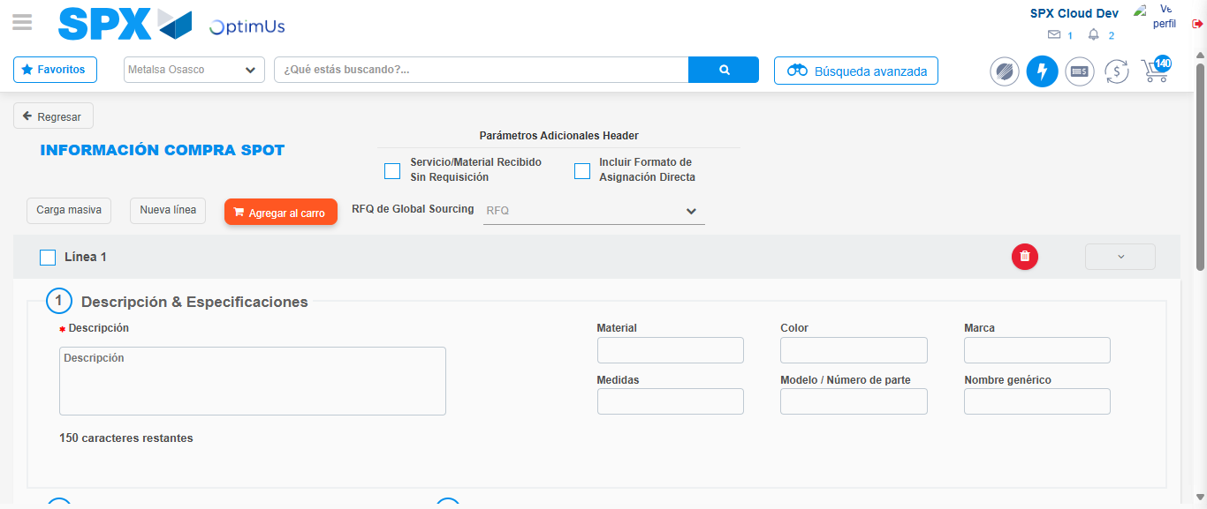Image file-name: QC_Testing-tc002_SPX_Dev5_Crear_Requisicion_Spot_Con_FAD_Tipo_Cobro_CC-1790170371636

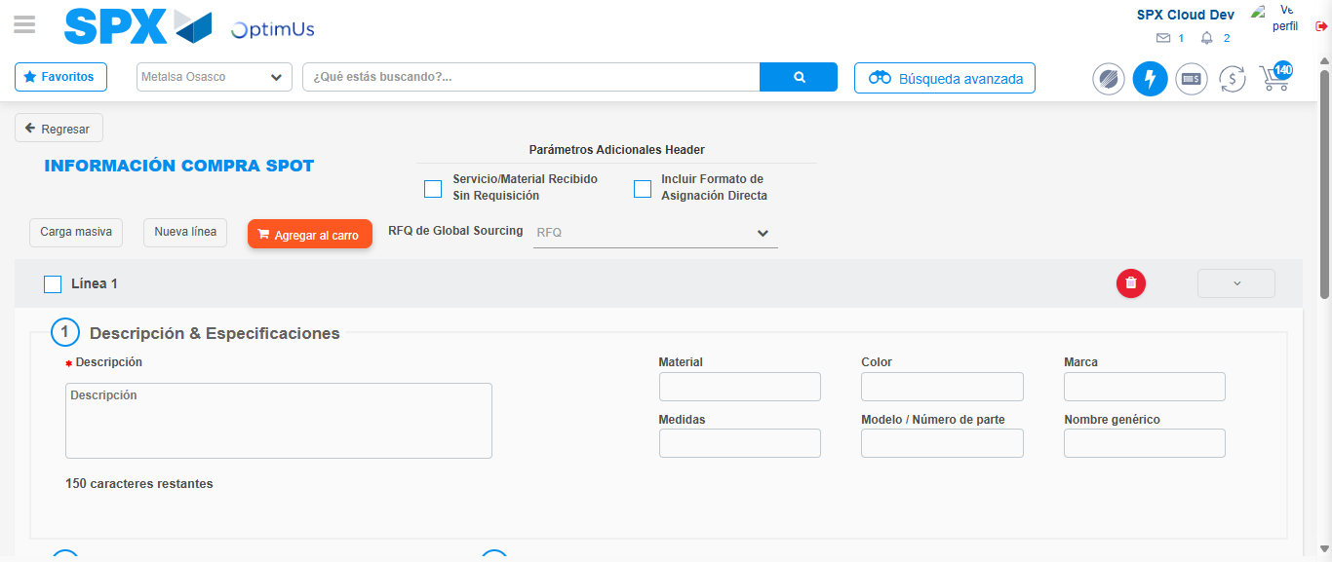Image file-name: QC_Testing-tc002_SPX_Dev5_Crear_Requisicion_Spot_Con_FAD_Tipo_Cobro_CC-1790170371923

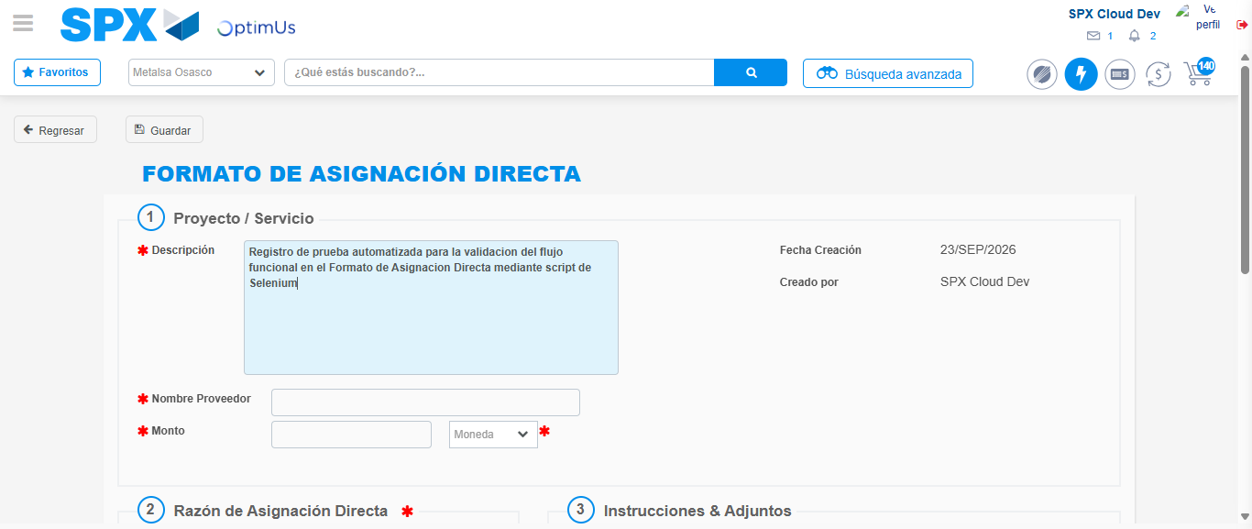Image file-name: QC_Testing-tc002_SPX_Dev5_Crear_Requisicion_Spot_Con_FAD_Tipo_Cobro_CC-1790170374773

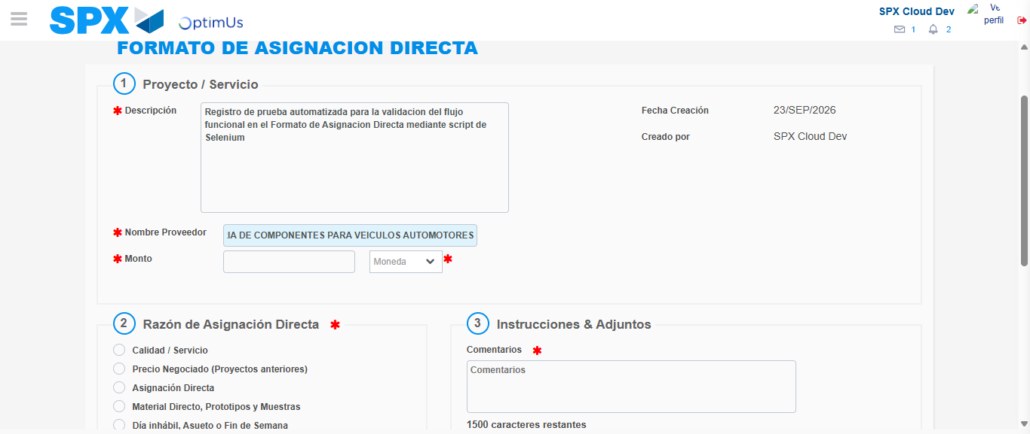Image file-name: QC_Testing-tc002_SPX_Dev5_Crear_Requisicion_Spot_Con_FAD_Tipo_Cobro_CC-1790170383842

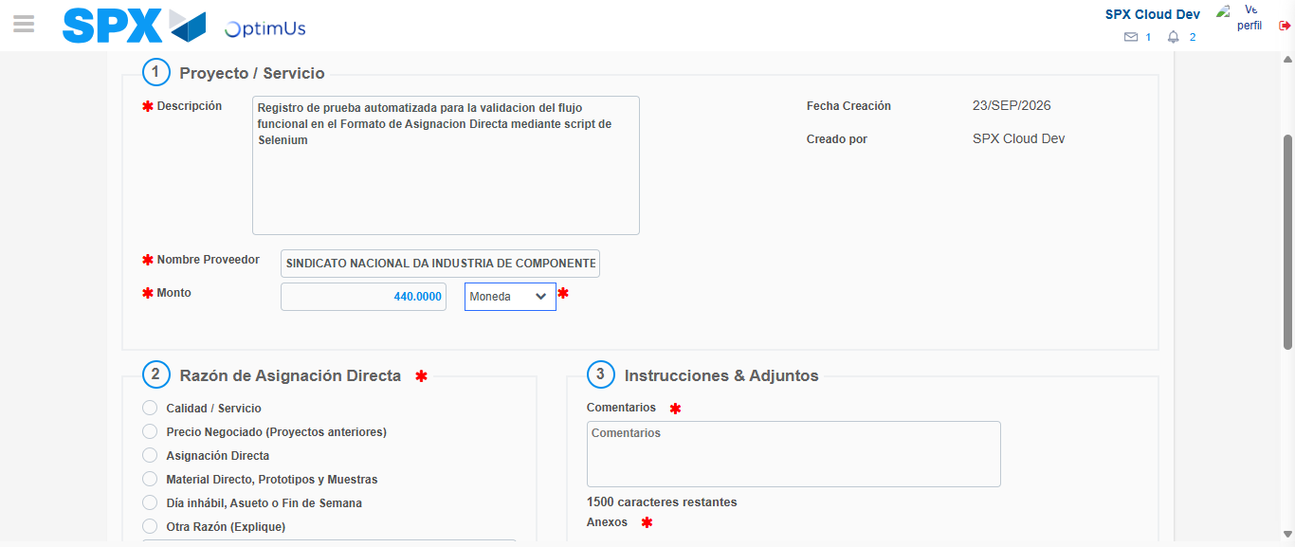Image file-name: QC_Testing-tc002_SPX_Dev5_Crear_Requisicion_Spot_Con_FAD_Tipo_Cobro_CC-1790170384326

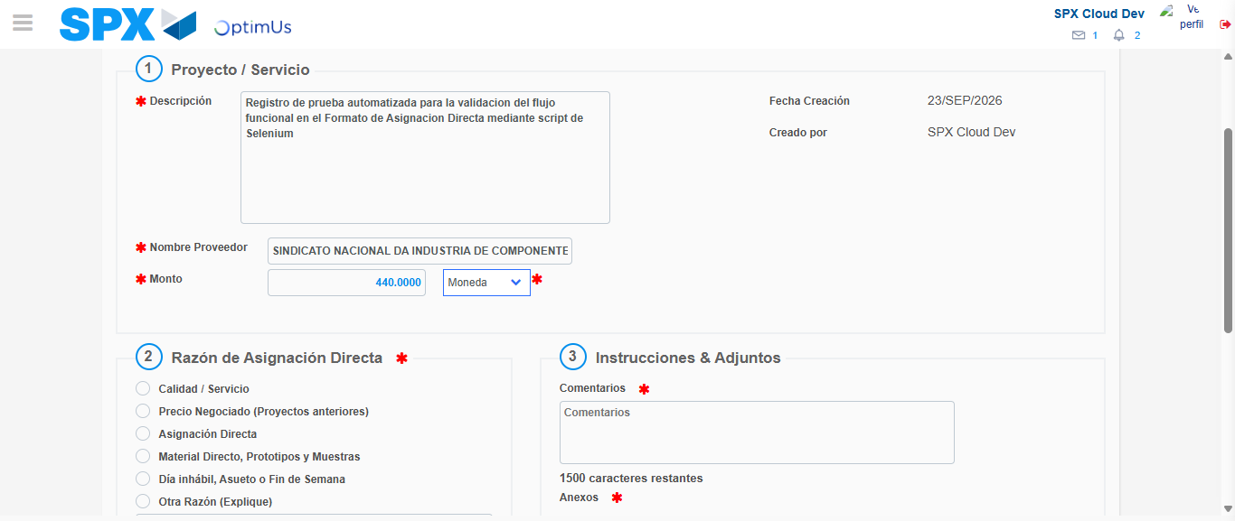Image file-name: QC_Testing-tc002_SPX_Dev5_Crear_Requisicion_Spot_Con_FAD_Tipo_Cobro_CC-1790170384579

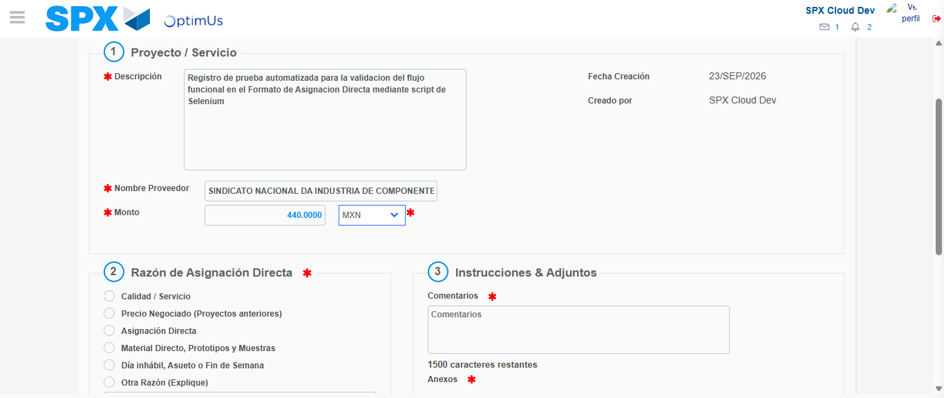Image file-name: QC_Testing-tc002_SPX_Dev5_Crear_Requisicion_Spot_Con_FAD_Tipo_Cobro_CC-1790170385021

Image file-name: QC_Testing-tc002_SPX_Dev5_Crear_Requisicion_Spot_Con_FAD_Tipo_Cobro_CC-1790170385258

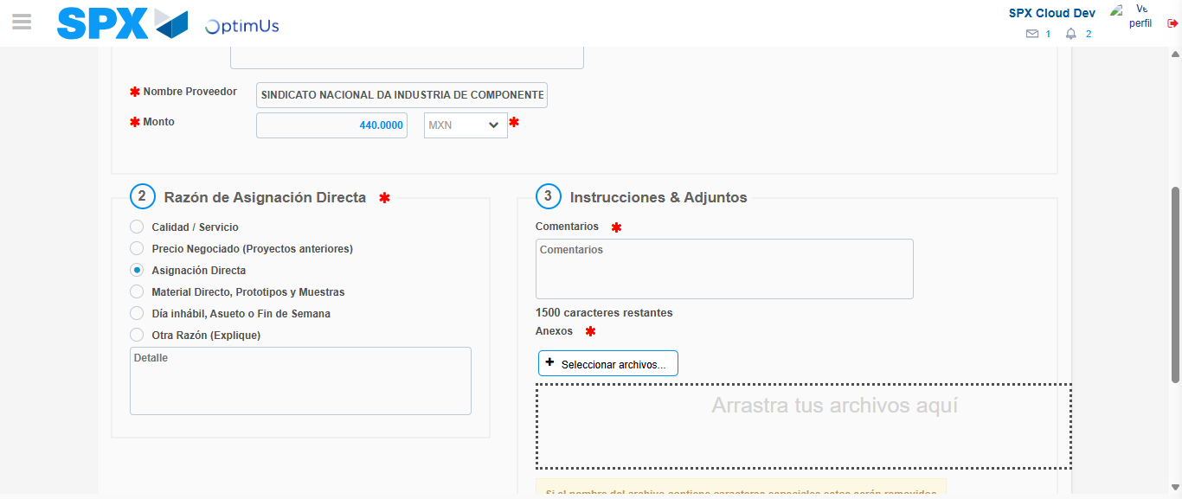Image file-name: QC_Testing-tc002_SPX_Dev5_Crear_Requisicion_Spot_Con_FAD_Tipo_Cobro_CC-1790170386127

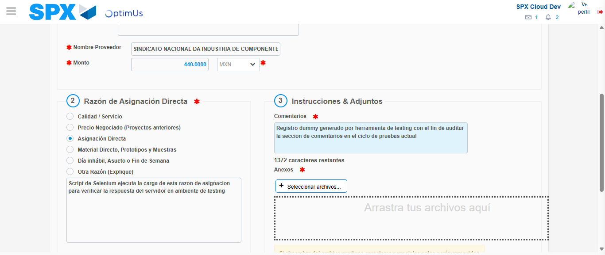Image file-name: QC_Testing-tc002_SPX_Dev5_Crear_Requisicion_Spot_Con_FAD_Tipo_Cobro_CC-1790170397216

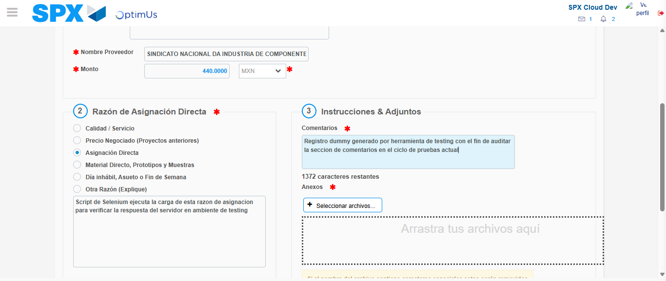Image file-name: QC_Testing-tc002_SPX_Dev5_Crear_Requisicion_Spot_Con_FAD_Tipo_Cobro_CC-1790170397915

Step 4 - Data Capture Spot Buy Requisition: Data captured correctly
Image file-name: QC_Testing-tc002_SPX_Dev5_Crear_Requisicion_Spot_Con_FAD_Tipo_Cobro_CC-1790170371636

Image file-name: QC_Testing-tc002_SPX_Dev5_Crear_Requisicion_Spot_Con_FAD_Tipo_Cobro_CC-1790170371923

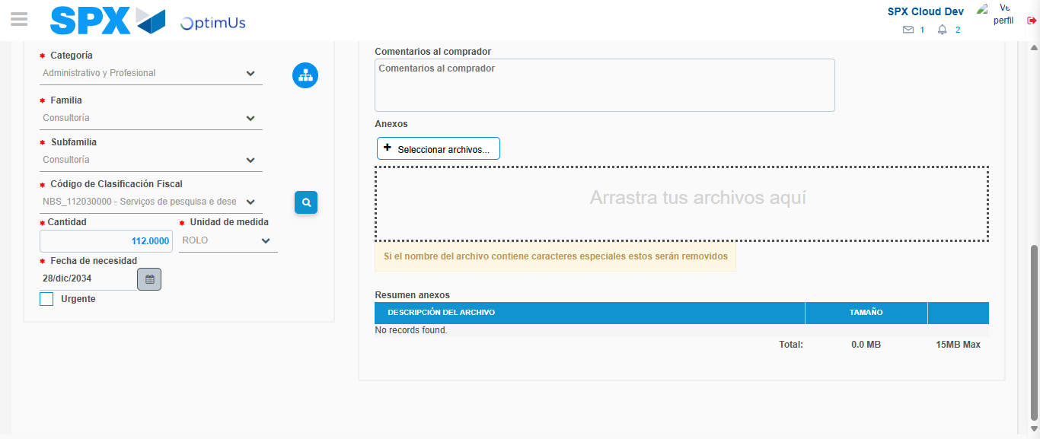Image file-name: QC_Testing-tc002_SPX_Dev5_Crear_Requisicion_Spot_Con_FAD_Tipo_Cobro_CC-1790170415867

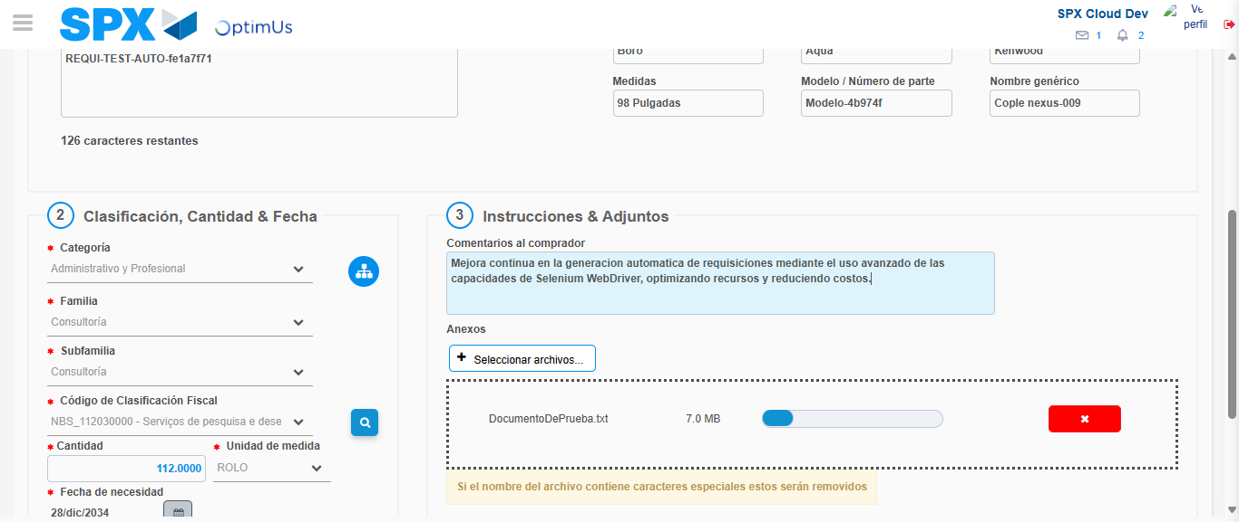Image file-name: QC_Testing-tc002_SPX_Dev5_Crear_Requisicion_Spot_Con_FAD_Tipo_Cobro_CC-1790170416692

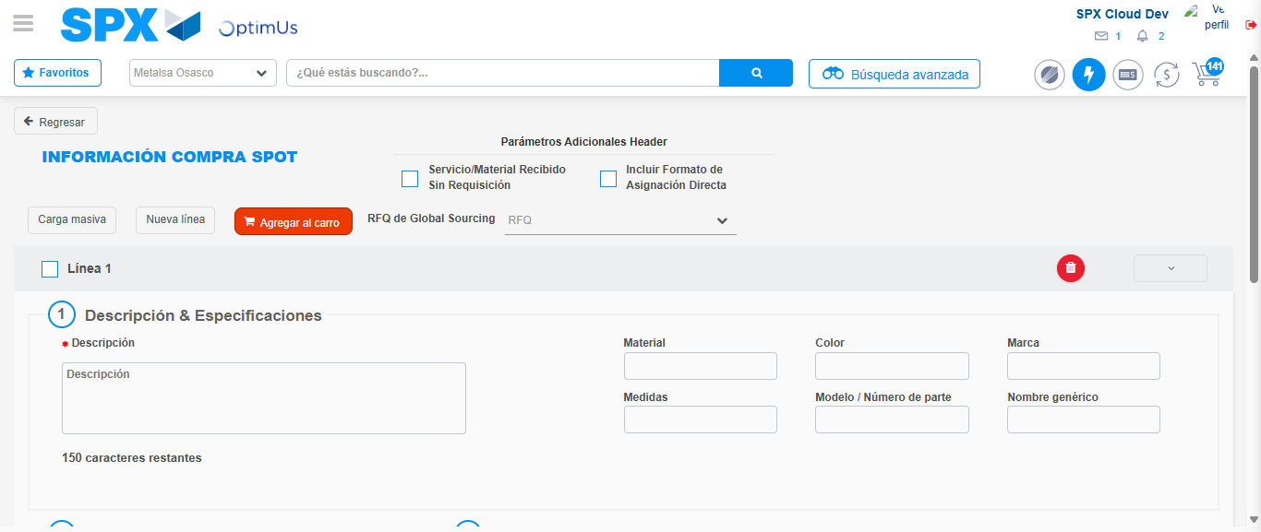Image file-name: QC_Testing-tc002_SPX_Dev5_Crear_Requisicion_Spot_Con_FAD_Tipo_Cobro_CC-1790170431016

Step 8 - Return to Main Page SPX : Return to Main Page SPX
Image file-name: QC_Testing-tc002_SPX_Dev5_Crear_Requisicion_Spot_Con_FAD_Tipo_Cobro_CC-1790170360873

Image file-name: QC_Testing-tc002_SPX_Dev5_Crear_Requisicion_Spot_Con_FAD_Tipo_Cobro_CC-1790170361494

Image file-name: QC_Testing-tc002_SPX_Dev5_Crear_Requisicion_Spot_Con_FAD_Tipo_Cobro_CC-1790170371298

Image file-name: QC_Testing-tc002_SPX_Dev5_Crear_Requisicion_Spot_Con_FAD_Tipo_Cobro_CC-1790170433245

Image file-name: QC_Testing-tc002_SPX_Dev5_Crear_Requisicion_Spot_Con_FAD_Tipo_Cobro_CC-1790170433428

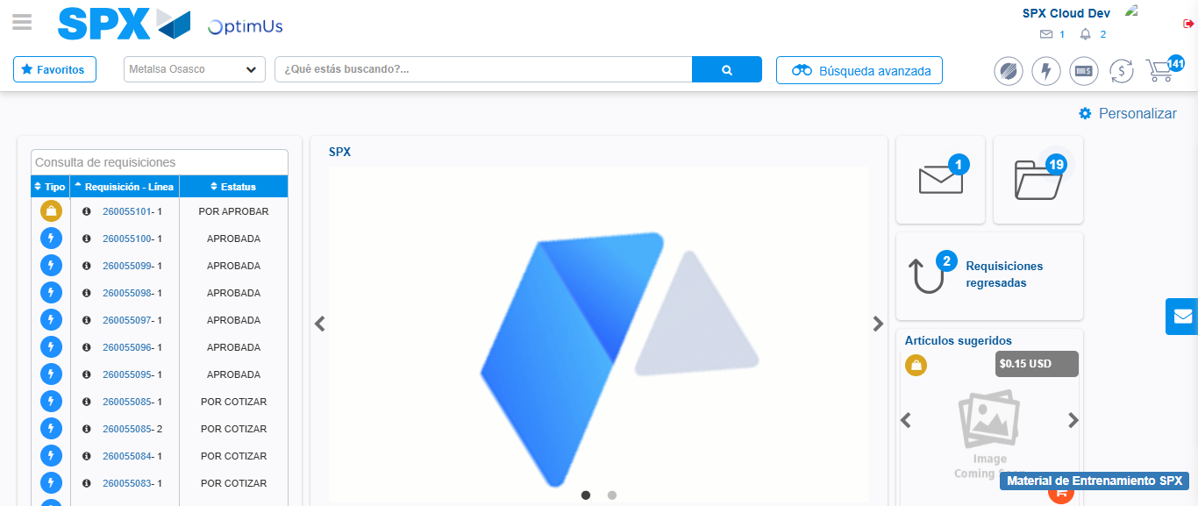Image file-name: QC_Testing-tc002_SPX_Dev5_Crear_Requisicion_Spot_Con_FAD_Tipo_Cobro_CC-1790170454686

Step 9 - Log Out : Log Out SPX
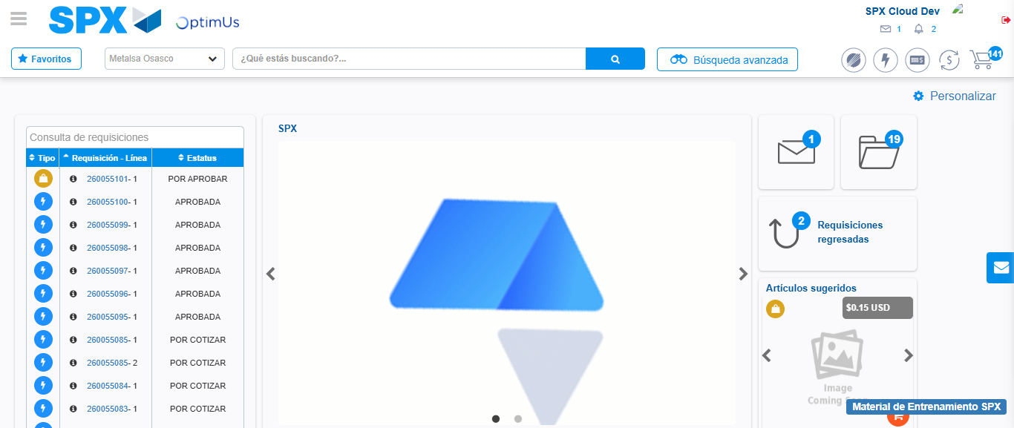Image file-name: QC_Testing-tc002_SPX_Dev5_Crear_Requisicion_Spot_Con_FAD_Tipo_Cobro_CC-1790170455031

